**Automated Symptom Diagnosis Chatbot**

**Belfadla Fatima Ezzahra**

Faculty of Science Eljadida

Department of IT

Chouaïb Doukkali University, Eljadida, Morocco

**Abstract:**

In the last few years, intelligent chatbot systems have been prevalent in various application fields, especially in healthcare and pharmacy. Therefore, the demand for such online consulting services like chatbots is getting higher. However, most communications between potential patients and pharmacies are performed manually, which is very time-consuming procedure. In this paper we present a medical chatbot that provides diagnosis based on the symptoms provided to the system. Our chatbot was developed by AI models, which are already integrated into the Rasa framework.

**Keywords:** Rasa framework, Symptoms Diagnosis, Chatbot, AI.

1. **INTRODUCTION**

Recently Chatbots, or conversational AI Interfaces, provide individuals a new way to interact with computer systems. Chatbots allow users to have conversations with the system by asking questions in the way that they would with another human beings. The current adoption rate of chatbots on computer chat platforms is very high. Such robots use artificial intelligence to understand human input and respond accordingly. The core technology for the rise of chatbots is “Natural language processing” (NLP). The recent advancements in NLP have allowed chatbots to be more receptive than ever. Today, humans can interact with the chatbot systems anytime, anywhere. Chatbots can perform predictive tasks (especially in the medical field), which is now possible with advances in artificial intelligence and data mining technology. Healthcare, agriculture and education are important areas that need the most attention. In today’s world, with the change in lifestyle and the current pandemic, illnesses have increased in the general population. As a result, the need for hospitals and doctors have increased substantially. Patients have to spend their time waiting to be taken care of by the doctors. Also, doctors have an immense amount of workload with the number of visits they have. Thus, the future of healthcare depends on the ability of care providers to perform accurate remote diagnosis.

The proposed solution is to deliver a healthcare chatbot that uses AI and ML which will provide different services to the user and basic details about the disease like it’s symptoms, treatment. A text based conversational chatbot engages with patients about their medical conditions and gives a reliable diagnosis to support their symptoms.

Hence, people will have a thought about their health and have the proper protection. Healthcare chatbot has a great impact on the health and pharmaceutical sector. It is highly reliable as the factor of human error gets completely erased. So, this paper focuses on designing such a healthcare chatbot which is free of cost.

The rest of this paper is structured as follows:

Section 2 explores the relevant work associated with Healthcare Chatbot.

Section 3 discusses the proposed approach. section 4 represents the results and experimental analyzes followed by the last section 5 contains the conclusion & Future work.

1. **RELATED WORKS:**

Many research articles have been written on the medical fields. Although these articles share a common goal, they differ in the proposed methods.

In this paper the authors have developed an interactive talking chatbot. This chatbot basically focuses on suggesting appropriate diet plans to the user according to their weight and height and other factors. [1] The chatbot uses different dataset and provides the necessary output. They have used natural language processing and built the chatbot in python programming language using different libraries and data structures.

In this paper the authors [2] have created a chatbot application using machine learning that can diagnose the disease and provide the solution or connect with a doctor. The patient's symptoms are predicted using pattern matching. They have also provided a map with the location of nearby doctors using Google maps API. They have used NLP and NLU for this application. They have trained this chatbot using Dialog Flow tool.

The idea in this paper is to create a Chatbot that can diagnose the disease [3]. Technologies used are RNN, Deep Learning, NLP, NLG. User sends text or voice message with the help of Google API. One of the supervised ML algorithms named SVM Algorithm is used for classification. Different kinds of letters such as suffixes or prefixes are removed with an algorithm named Porter. SQL is used for database. Tokenization is used. This is Web based system.

This paper talks about [4] pediatric medicine Chatbot. The Chatbot gives information on generic medicine for children. Left and right parsing algorithm is used to come up with the result. After consultation with Chatbot, the chatbot will prescribe generic medicines including proper intake, dosage, drug reaction, precaution. The developed system can be used by the parent of the patients who need medical assistance in taking the right generic medicine for certain ailment.

1. **PROPOSED APPROACH:**

Before we get deeper, we will attempt summarize our approach to perform the diagnosis based on the symptoms described by the user.

Outside of Rasa’s built-in intent classification and entity extraction models, this will be unsupervised modelling approach and can be broken up into 5 steps (figure 1):

1. Extract symptoms (as entities) from the users messages using Rasa’s built in entity extraction functionality.
2. Convert each symptom to a sentence vector using Spacy.
3. Compare this vector to a dataset of known symptoms (and their vectors) based on cosine similarity and flag any symptoms which appear (similarity threshold = 85%) in a binary “illness” vector
4. In a similar fashion compare the illness vector of to a dataset on known illnesses
5. If any illness is > 50% similarity, diagnose user with most similar illness, otherwise inform user there is no diagnosis.

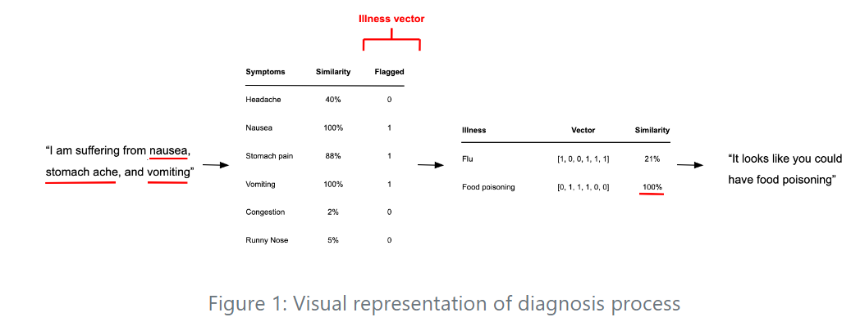

It’s worth pointing out that I chose to use a cosine similarity-based approach for the illness vector comparison as it will handle cases whereby a user experiences 2 out of 2 symptoms of one illness in addition to 3 others not associated with the illness.

1. **RESULTS:**

The trained model is running as designed and by adding more intents, the bot can predict more accurately thus enhancing the user experience. The chatbot is also trained to handle cases whereby a user experiences 2 out of 2 symptoms of one illness in addition to 3 others not associated with the illness. Following figures are the results and outputs of the services provided by Symptom Diagnosis Chatbot.

1. **CONCLUSION & FUTURE WORKS:**

Thus, we have successfully proposed a Symptom Diagnosis chatbot system using RASA Framework. As technology is growing in various domains, healthcare is one such important domain. So, our chatbot helps the patients to get the instant information related to the disease with 24x7 service. This proposed system will help our country in healthcare domain. And such services will help the patient to get a better understanding of the problems they are facing. It will also help in reducing the burden from hospitals when there are many patients to handle.

In future work, we aim to Improve our bot to obtain more information from the user (gender, age, medical history).

1. **REFERENCE:**

[1]: Bennet Praba, M. S., Sen, S., Chauhan, C., & Singh, D. (2019). Ai healthcare interactive talking agent using Nlp. Int J Innov Technol Explor Eng, 9, 3470-3473.

[2]: Raj, P., Murali Krishna, R., Krishna, S. M., Vardhan, K. H., & Rao, K. (2019). Emergency patient care system using chatbot. Int. J. Technol. Res. Eng, 6.

[3]: Athota, L., Shukla, V. K., Pandey, N., & Rana, A. (2020, June). Chatbot for healthcare system using artificial intelligence. In 2020 8th International Conference on Reliability, Infocom Technologies and Optimization (Trends and Future Directions)(ICRITO) (pp. 619-622). IEEE.

[4]: Comendador, B. E. V., Francisco, B. M. B., Medenilla, J. S., & Mae, S. (2015). Pharmabot: a pediatric generic medicine consultant chatbot. Journal of Automation and Control Engineering, 3(2).